Lab Session – Day 8

**Question:**

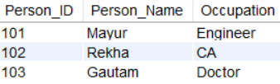Use ExcelR. Create table Profession with below fields and data.

Alter a table by

* Adding a new column DOB (Date of birth) after Person_Name
* Changing the data type of DOB so that it accepts date-time values

The output should look as shown in below image.

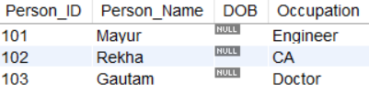

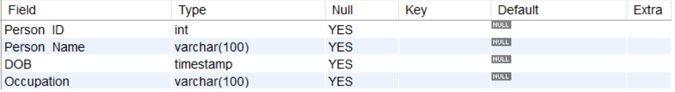

**Solution:**

Write the below query in MySQL workbench.

